Code Explanation –

Import libraries –

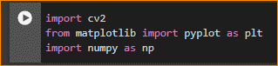

Read the image -



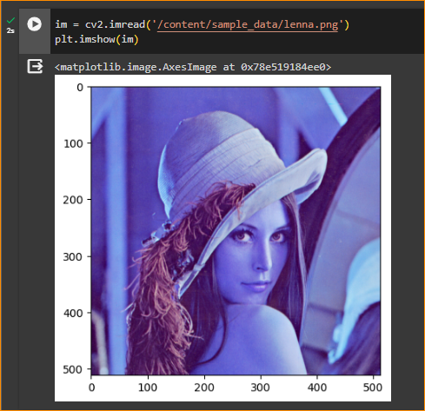

Get image shape-

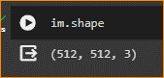

The result (512, 512, 3) represents the shape of a NumPy array, likely representing an image in a format commonly used in computer vision.

* The first value (512) corresponds to the height of the image.
* The second value (512) corresponds to the width of the image.
* The third value (3) indicates that there are three channels. In the context of computer vision, this often means that the image is in color, and the three channels are Red, Green, and Blue (RGB).

So, the shape (512, 512, 3) suggests that you have a color image with a **height of 512 pixels**, a **width of 512 pixels, and three color channels.** Each pixel in the image has three values corresponding to its RGB color.

Convert the RGB image into a grayscale image -

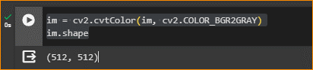

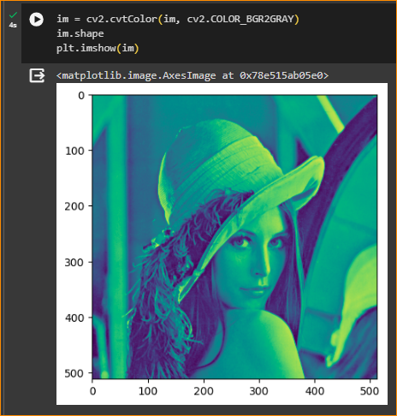

Now it has only one channel

Define vertical and horizontal filter kernels

This only extract only vertical edges.

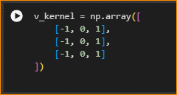

Do the Filtering –

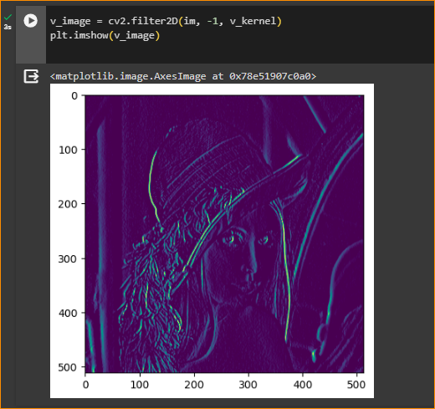

Display results –

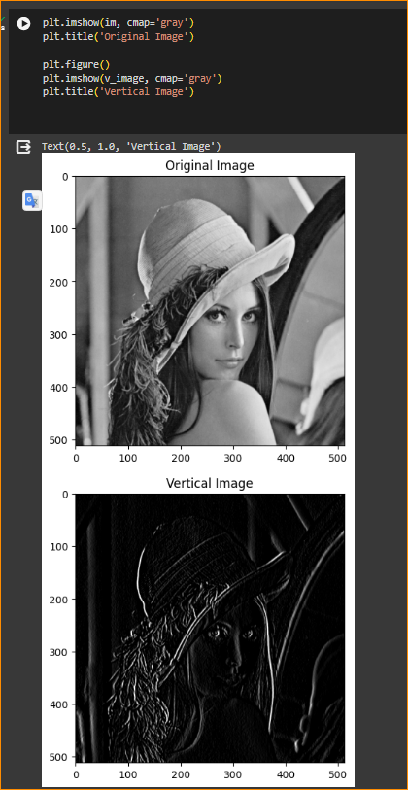

Do changes - Now add the following code segments to the uploaded notebook.

In the 5th code cell that defines v_kernel, past the following code under the existing code.

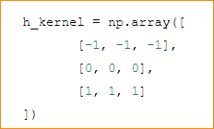

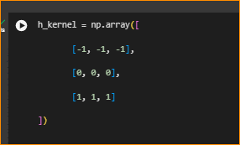

In the 6th code cell that assigns the value for the v_image, insert the following code under the existing code.



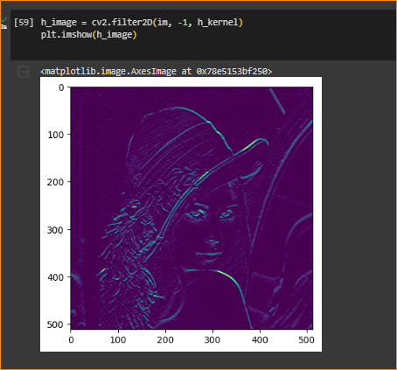

In the 7th code cell that displays the output image with the vertical image, inset the following code after the existing code.

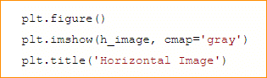

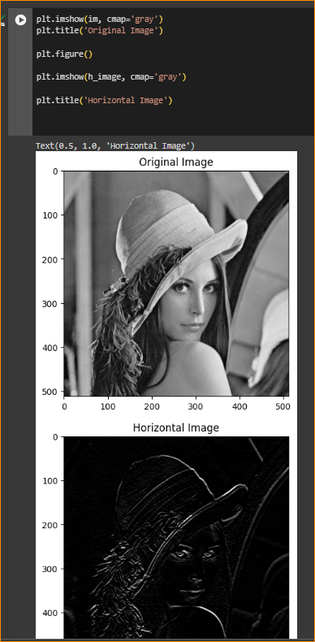

What can you say about the additional output image with edges? How does the kernel values affect the output?